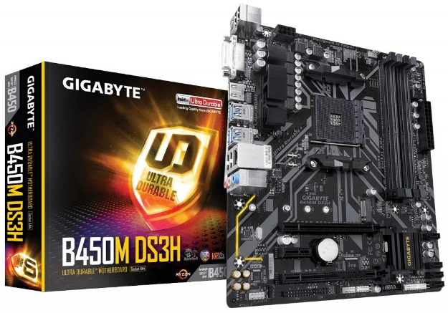

inner

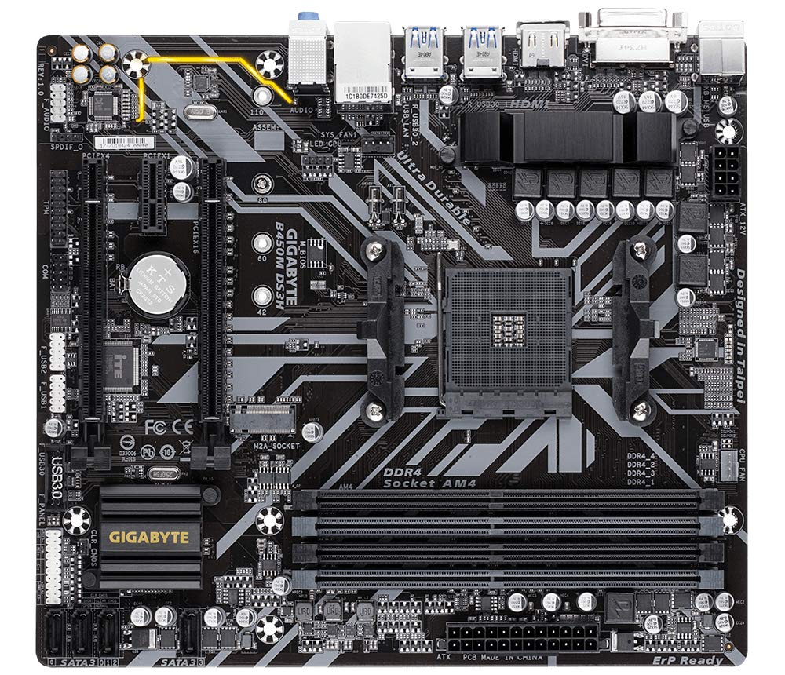

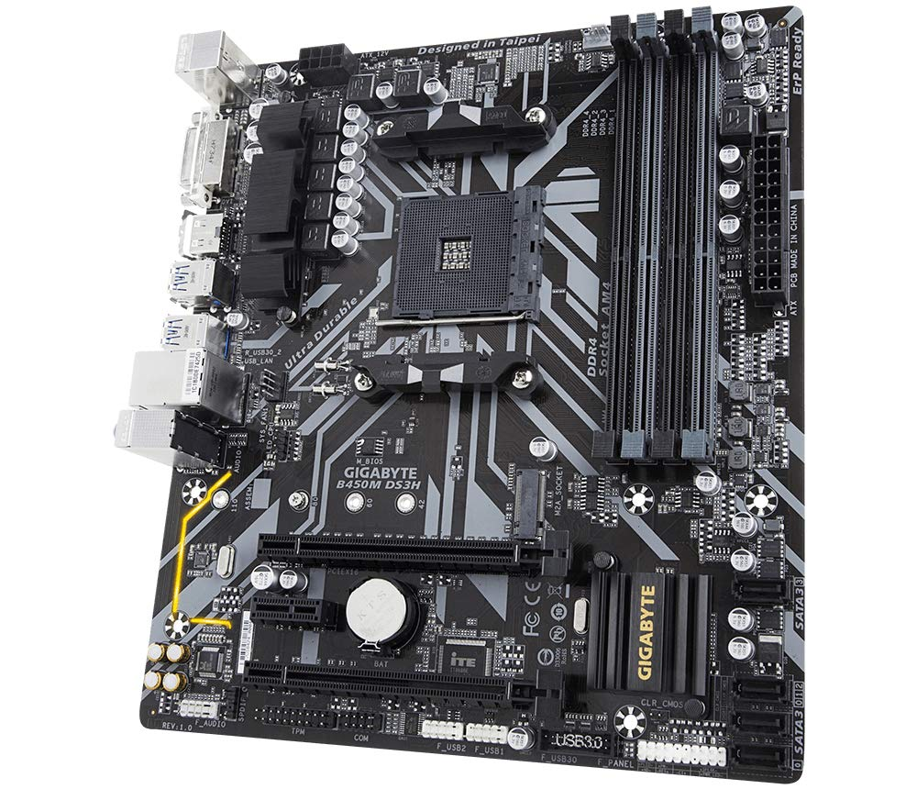

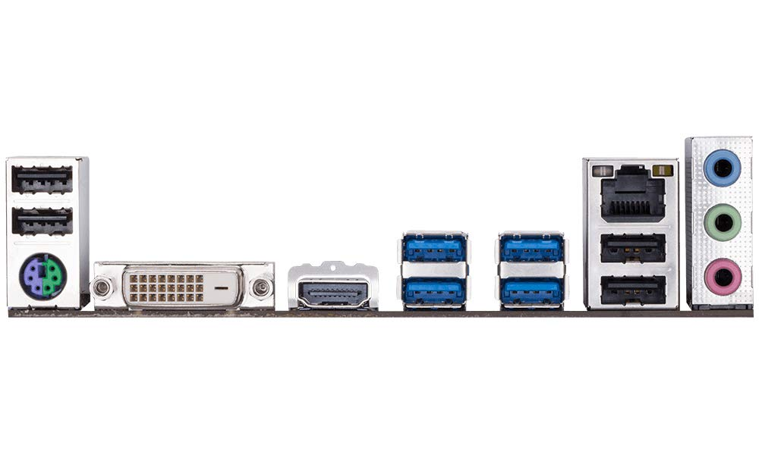

Gigabyte B450M DS3H (AMD Ryzen AM4/M.2/HMDI/DVI/USB 3.1/DDR4/Micro ATX/Motherboard)

-31% ₹7,599.00₹7,599.00

M.R.P.: ₹10,999.00₹10,999.00

|  |  |
| --- | --- |
| Brand | GIGABYTE |
| CPU Socket | Socket AM4 |
| Compatible Devices | Personal Computer, CPU |
| RAM Memory Technology | DDR4 |
| Compatible Processors | AMD 2nd Gerenration Ryzen, AMD 1st Gerenration Ryzen |

**About this item**

* Supports AMD 2nd Generation Ryzen/ Ryzen with Radeon Vega Graphics/ 1st Generation Ryzen Processors
* Dual Channel Non-ECC Unbuffered DDR4, 4 DIMMs